## Skill-React

**React Hands-on Lab:** **Cohort Tracker**

# Code:

## Terminal Instructions:

**# 1. Create a new React app named "cohorttracker"**

**npx create-react-app cohorttracker**

**# 2. Move into the project folder**

**cd cohorttracker**

**# 3. Open the project in Visual Studio Code (optional)**

**code .**

**# 4. Start the development server**

**npm start**

# Codes:

## CohortDetails.module.css:

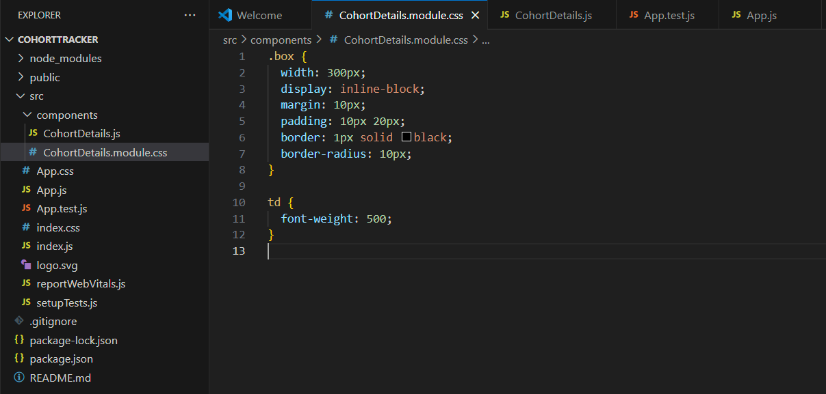

## CohortDetails.js:

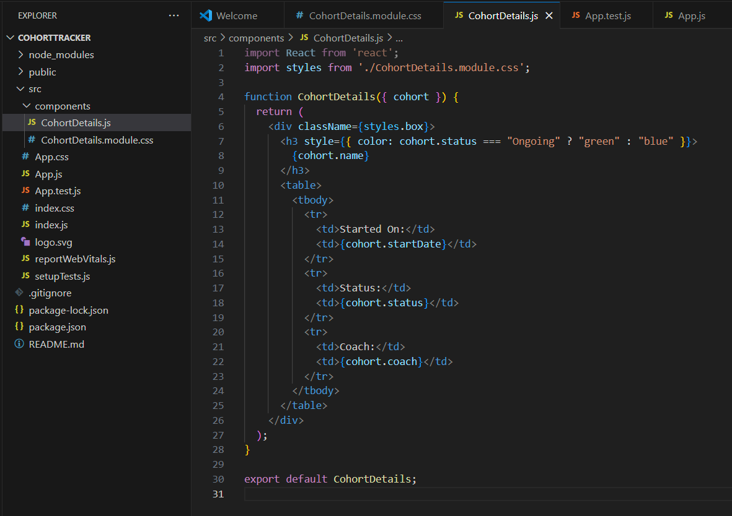

## App.js:

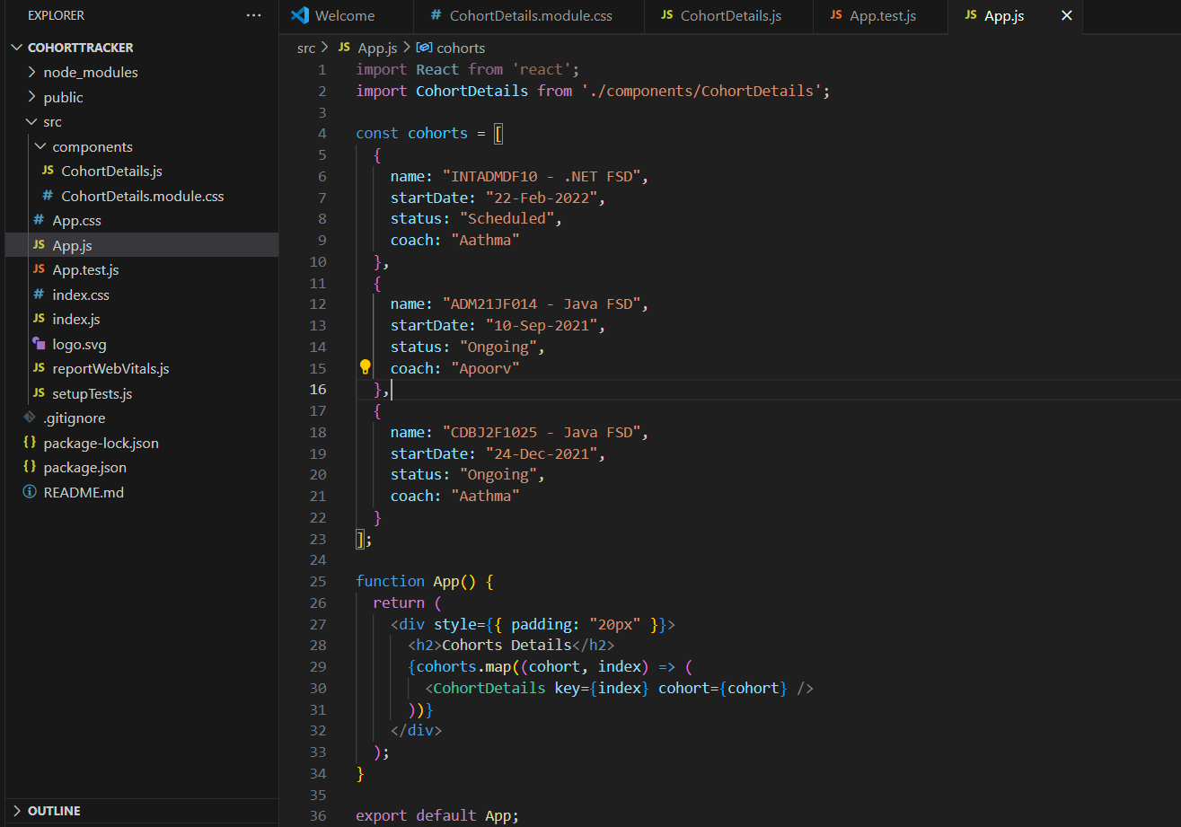

# Output:

